Counting objects from nature – This might include doing nature hunts for a certain number of objects
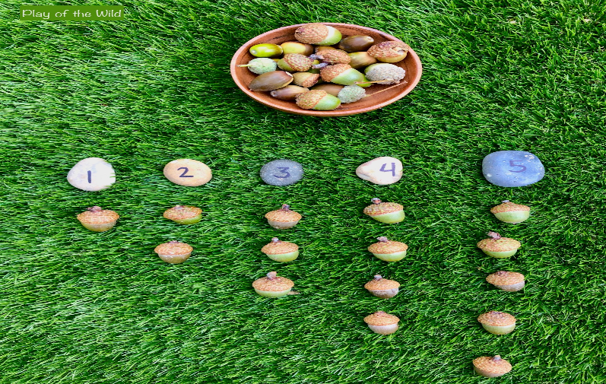
- Nature number line – Hang rope between trees (or along the fence if concerned about children running into the rope) and provide pegs. Children can hang up and order numbers to make a number line. Children might collect things like leaves to pin to correspond with the value. Which number comes first? Which number is bigger (has a larger value)? How do you know?
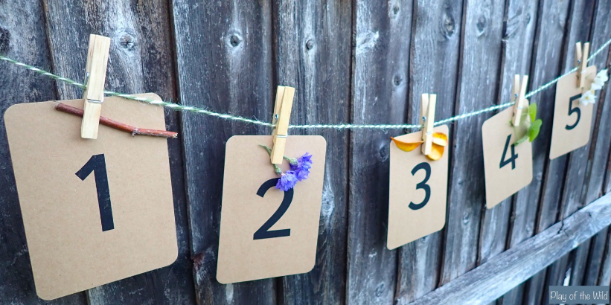

- Counting picture– Children can create a picture using 10/20 objects they find in nature. Children have to find the objects and make sure they have the exact number of objects.

- Number writing– Children can practice writing numbers with chalk or tracing over chalk numbers by painting with water.

- Skittles & bowling– Children can play games such as skittles, bowling and other target games. They can identify numbers on the games, count the number of skittles or targets that are hit, add up points, take away how many objects have been knocked over, and see how many are left. There are lots of opportunities for counting, adding and subtracting with these types of garden games.
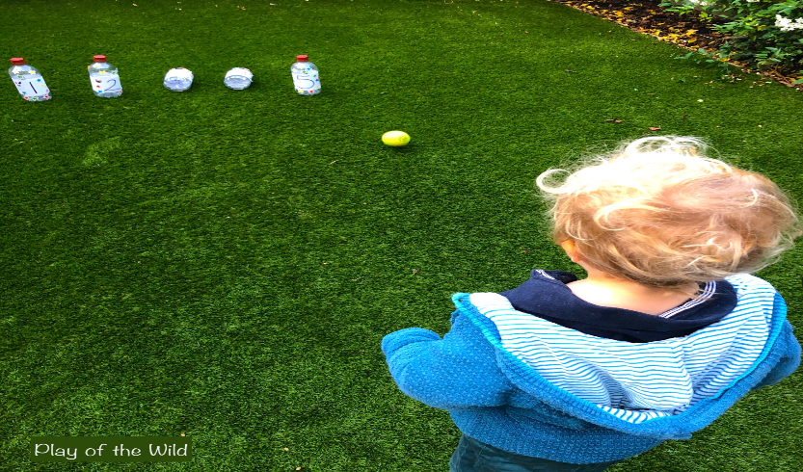

- Ordering objects by length – children usually find it easy to compare two objects but may need more practice when comparing 3 or more objects.

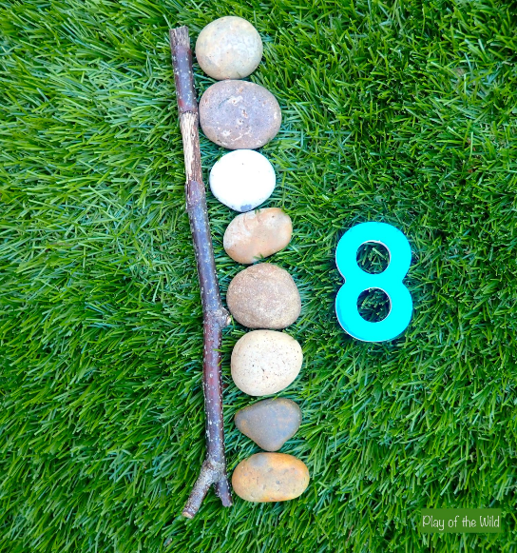
- Measuring with non-standard units– Children can practice measuring objects with non-standard units (e.g. how many stones long is the stick). This is the next step after comparing lengths, but before measuring with standard units such as cm or inches. How many pinecones long is your toy bus? Which is shorter? How do you know?

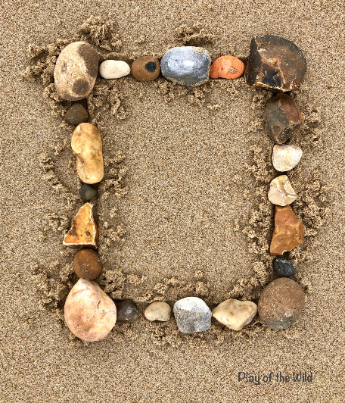
- Shapes– Children can make shapes out of sticks, rocks, etc.

- Shape hunt– Children may go on 2D and 3D shape hunts in nature. Which shape is it? How do you know?
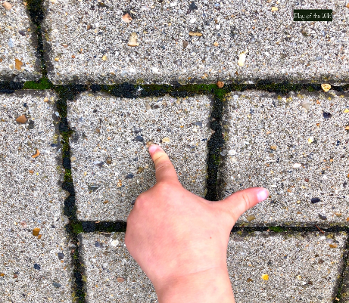

- Measuring height – Children can measure their height in rocks, pinecones or sticks (e.g. non-standard units) by laying down on the ground. Children can then count to see how many pinecones, sticks, or rocks tall they are. Who is taller? How do you know? Is there another way to show this?

- Measuring natural objects– Children can measure natural objects, such as plants, with a ruler. They can also go on a ‘meter hunt’ or ‘foot hunt’ to see if they can find things in nature that are a foot or meter.

